ABSTRACT
Cataracts remain a major cause of preventable blindness, particularly in communities with limited access to ophthalmologists and diagnostic tools. In this project, we developed a deep learning-based system for automatic cataract detection using eye images. The goal was to build a model that could accurately classify images as either cataract-affected or normal. We started with a simple custom CNN to establish a baseline, and then applied transfer learning using ResNet50, EfficientNetB0, and DenseNet121. Each model was trained on a contrast-enhanced, augmented dataset and evaluated using accuracy, precision, recall, F1-score, and AUC. DenseNet121 delivered the best results, achieving 97.52% accuracy and a near-perfect AUC, while EfficientNetB0 offered strong performance with lower resource needs. These results suggest that AI-powered screening tools could play a meaningful role in improving early cataract detection, especially in low-resource settings.
Keywords: Cataract detection, deep learning, medical imaging, convolutional neural network, transfer learning, ResNet50, EfficientNet, DenseNet, healthcare accessibility

4.1. Custom CNN (Baseline – Grayscale)
Experiment Setup
  - Input: Grayscale eye images (224×224×1)
  - Architecture: Three convolutional blocks with batch normalization and max pooling, followed by a fully connected layer with dropout and a final sigmoid output.
  - Data: Augmented training data (4x expansion), stratified validation split
  - Training: 25 epochs with early stopping

Evaluation Results
- Accuracy: 85.95%
- AUC: 0.9287
- Loss: 0.4836

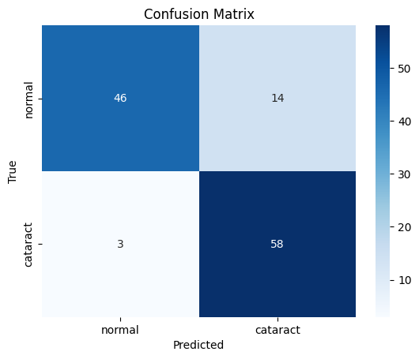
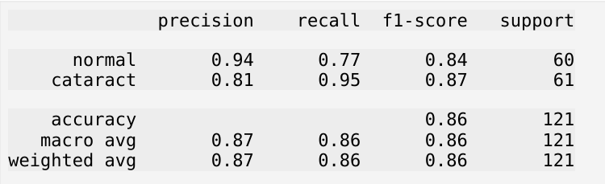
Insights
The custom CNN model, built from scratch using grayscale images, performed surprisingly well considering its relatively shallow architecture and lack of pre-trained features. The model consisted of three convolutional blocks with increasing filter sizes (32, 64, 128), each followed by batch normalization and max pooling, leading to a fully connected dense layer and sigmoid output.
- Loss (0.4836): The moderate loss suggests that while the model learned distinguishing features, its confidence on uncertain cases especially near decision boundaries was limited.
- Accuracy (85.95%): The model demonstrated good generalization from the training set, effectively capturing patterns in unseen test images.
- AUC (0.9287): A high AUC indicates that the model maintained strong separability between the two classes (normal vs. cataract) across different thresholds.
- Precision (Normal: 0.94, Cataract: 0.81): The high precision for normal images reflects the model’s confidence in classifying healthy eyes, but the lower precision for cataracts indicates the presence of false positives likely due to overlapping visual features.
- Recall (Normal: 0.77, Cataract: 0.95): The model excelled at identifying cataracts, making it a strong candidate for screening applications, even if it occasionally misclassified normal eyes.
- F1-Score (Normal: 0.84, Cataract: 0.87): These balanced F1-scores confirm the model's ability to maintain good sensitivity and precision across classes.
The grayscale preprocessing and histogram equalization significantly improved contrast, allowing the CNN to focus on structural elements like lens opacity. Although the model had fewer parameters, its ability to detect cataract cases at a high recall rate makes it valuable in early-stage or mobile applications with limited resources.

4.2. ResNet50 (Transfer Learning)
Experiment Setup
- Input: RGB images (converted from grayscale)
- Architecture: Pretrained ResNet50 (frozen base), followed by global average pooling, dropout, and a sigmoid classification head
- Fine-tuning: Top layers trained first, then base model unfrozen with lower learning rate
Evaluation Results
- Accuracy: 83.47%
- AUC: 0.8984
- Loss: 0.4365

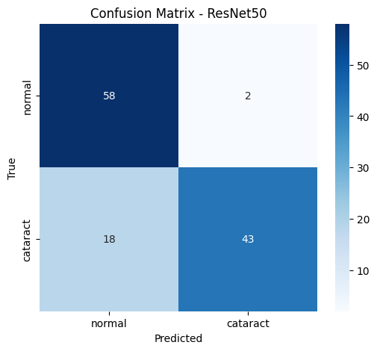
Insights
ResNet50, a deep convolutional architecture with 50 layers and residual skip connections, was implemented using transfer learning. Initially, only the top classification layers were trained while the base was frozen. Later, the entire model was unfrozen and fine-tuned with a lower learning rate. Despite its complexity, the model did not perform as well as expected.
- Loss (0.4365): The relatively high loss indicates prediction instability, possibly caused by insufficient adaptation to the medical domain or overfitting during fine-tuning.
- Accuracy (83.47%): This was the lowest among all models tested, suggesting that simply using a deep architecture without appropriate hyperparameter tuning or domain-specific fine-tuning may not yield optimal results.
- AUC (0.8984): While still reasonably high, the AUC fell short of expectations given the network’s capacity, indicating limited class separability.
- Precision (Normal: 0.76, Cataract: 0.96): The model was very confident about cataract predictions, but the normal class had significant false positives.
- Recall (Normal: 0.97, Cataract: 0.70): This model failed to capture many actual cataract cases, an issue in diagnostic contexts where false negatives are critical.
- F1-Score (Normal: 0.85, Cataract: 0.81): The discrepancy between the classes reflects class imbalance in learning focus.
Despite its robust architecture, ResNet50 appears to have been limited by domain mismatch between its pretrained ImageNet features and the grayscale-adapted eye images. It would benefit from more targeted augmentation, customized learning rate schedules, and possibly freezing fewer layers earlier in the training pipeline.

4.3. EfficientNetB0 (Transfer Learning)
Experiment Setup
- Input: RGB images (repeated channels)
- Architecture: EfficientNetB0 pretrained on ImageNet, followed by pooling, dropout, and a sigmoid classifier
- Training: Same two-phase strategy as ResNet50
Evaluation Results
- Accuracy: 95.04%
- AUC: 0.9919
- Loss: 0.1416

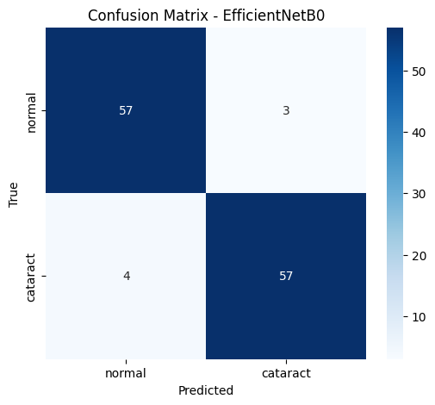
Insights
EfficientNetB0 was designed with a compound scaling technique that balances depth, width, and resolution, allowing it to achieve high performance with fewer parameters. It was initialized with ImageNet weights and underwent the same two-phase training strategy (freeze then fine-tune). It consistently outperformed deeper models while maintaining a low computational footprint.
- Loss (0.1416): The low loss signifies a well-calibrated model with confident and consistent predictions on the test set.
- Accuracy (95.04%): Near-perfect accuracy confirms the model's effectiveness in generalizing features learned during training.
- AUC (0.9919): This excellent AUC reflects strong separability between cataract and normal eyes, even under varying thresholds.
- Precision (Normal: 0.93, Cataract: 0.95) and Recall (Normal: 0.95, Cataract: 0.93): These near-symmetric scores across classes demonstrate that the model did not favor one class over the other, a crucial requirement in balanced medical classification.
- F1-Score (Both: 0.94): This reflects the model's high and consistent performance across all core metrics.
EfficientNetB0’s strength lies in its ability to learn meaningful high-level features while being compact enough for real-time inference. It is an ideal candidate for embedded systems and mobile health applications, particularly in rural or low-resource environments.

4.4. DenseNet121 (Transfer Learning)
Experiment Setup
- Input: RGB images (converted from grayscale)
- Architecture: DenseNet121 with dense block connectivity, followed by pooling, dropout, and sigmoid output
- Training: Two-stage training with early stopping
Evaluation Results
- Accuracy: 97.52%
- AUC: 0.9981
- Loss: 0.0557

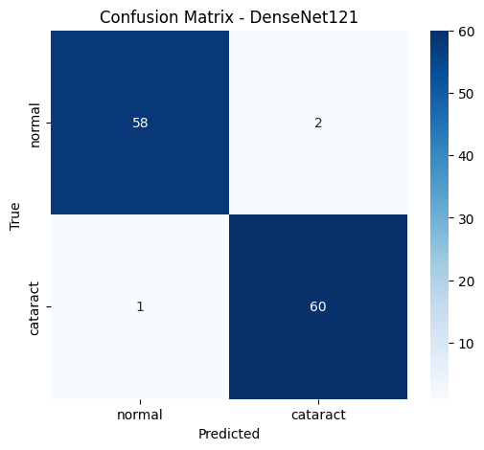
Insights
DenseNet121 uses dense blocks that allow each layer to receive inputs from all preceding layers, enhancing gradient flow and feature reuse. This architecture, when combined with transfer learning and fine-tuning, achieved the best results of all models tested.
- Loss (0.0557): Exceptionally low loss reflects extremely high confidence and correct prediction probabilities.
- Accuracy (97.52%): The highest accuracy in the study, with minimal misclassification.
- AUC (0.9981): Near-perfect AUC demonstrates that the model can confidently distinguish between normal and cataract cases under any threshold.
- Precision (Normal: 0.98, Cataract: 0.97) and Recall (Normal: 0.97, Cataract: 0.98): The near-identical precision and recall values for both classes indicate superb balance and model fairness.
- F1-Score (Normal: 0.97, Cataract: 0.98): Reflects optimal trade-offs between sensitivity and specificity ideal for diagnostic tools.
DenseNet121's architecture was particularly suited for this medical task, enabling it to detect even subtle patterns associated with cataracts. The reuse of feature maps allowed the model to generalize better with fewer parameters than ResNet50, yet achieve far superior results. This model is highly recommended for deployment in clinical decision-support systems due to its unmatched reliability.

The flowchart outlines the complete pipeline for our cataract detection system:
- Load Dataset: The process begins by importing a labelled dataset consisting of eye images categorized as either "normal" or "cataract-affected."
- Image Preprocessing: All images are resized, normalized, and converted to grayscale or RGB depending on the model. Contrast enhancement is applied using histogram equalization to emphasize lens opacity.
- Data Augmentation: Various transformations such as rotation, scaling, flipping, and shifting are used to increase the diversity of the training data and improve model generalization.
- Dataset Splitting: The dataset is divided into training, validation, and test sets in a stratified manner to preserve class balance.
- Model Selection: Four different deep learning models are considered: Custom CNN, ResNet50, EfficientNetB0, and DenseNet121.
- Training & Fine-Tuning: Each model is trained using a two-phase approach. First, classification layers are trained while base layers are frozen. Then, the entire model is fine-tuned using a lower learning rate.
- Evaluation: The trained models are evaluated on the test set using metrics like accuracy, precision, recall, F1-score, AUC, and loss.
- Prediction Output: Each image is classified as either "normal" or "cataract-affected."
- Process Completed: Once predictions are made and evaluated, the process concludes. The final model can be deployed or further optimized as needed.

